The Annual Quality Assurance Report (AQAR)
of the IQAC – Year 2008-09

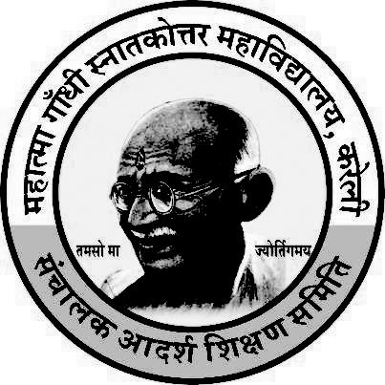

Track ID - MPCOGN13466
Submitted by
IQAC
Mahatma Gandhi Post-Graduate College,
Kareli. Distt. Narsingpur (M.P.)

ANNUAL QUALITY ASSURANCE REPORT OF THE IQAC FOR THE
SESSION 2008-09

A Q A R Report
Year of Report: 2008-09

Part A: The plan of action chalked out by the IQAC in the beginning of the year
towards quality enhancement and the outcome achieved by the end of the
year
1. Following was the action plan chalked out by the IQAC in the beginning
of the year for the academic session 2008-09

- Extension of Class rooms.
• Guest Lecture will be organized in different Departments.
- Celebration of important days of the year ( Environment day, Hindi day, Science day Gandhi Jaynti etc.)
- Alumni association meet & parent teacher meet to be continued.
- New Books for library will be procured.
- Healthy practices will be continued.
- To conduct seminars for PG students to develop presentation skills.
• To carry out B.J.C. students dissertation and job oriented projects.
• To brief details of Semester System to the students.
- To follow the academic calendar of University.
• To conduct cultural programme and sports for students.
1. Out come at the end of the Session

• The Construction of class rooms is partially completed.

• Guest Lecture are organized in different Departments.
- World AIDS day, Environment day, Hindi day and Science day were
celebrated.

• Independence day, Teachers Day Gandhi Jayanti, and Republic day were celebrated.

- Alumni, parent teacher meetings and health checkup camps were
organized.

- New Books for library have been purchased.
• Internship programme for U.G. students was conducted as semester system was introduced.

• U.G. students presented seminars through power point presentation on different topics.

- B.J.C. students carried out dissertation and job oriented projects.
• Details of Semester System were chalked out to the students..

• College has followed the academic calendar of University.

• Cultural programme and sports for students has been conducted.

Part B:-

1. Activities reflecting goals and objectives of the institution
Throughout the year, the regular activities of the college were organized as
per the academic calendar declared by Rani Durgavati Vishwavidyalaya Jabalpur,
which this college is affiliated.
Some of the activities are as under :
a) Sports Students participated at university level in various games.
b) Cultural activities which included Rangoli, Mehandi, Essay writing,
Debate competition, Antakshari, Solo song, Group Song , Dance
competition etc.
c) Students Union Election
d) NCC Activities.
e) Activities during NSS Camps.
f) Red Cross Activities

2. New Academic Programmes initiated (UG and PG)
Nil

3. Innovations in curricular design and transaction
Students of Commerce departments of the college go for excursion tour and field visits (Sugar Mill) to know their subject in a realistic way.

4. Inter-disciplinary programmes started
Nil

5. Examination reforms implemented
As the college is affiliated to the Rani Durgavati Vishwavidyalaya Jabalpur, it has to follow all rules and regulations, which are set by the University itself.
* The comprehensive continuous evaluation process has been strengthened with the introduction of Semester System.
* Marks of these exams are entered systematically in properly developed booklets and provision is made to notify the marks obtained to the students. These booklets are signed by the concerned teachers, HOD, Principal and then forwarded to Rani Durgavati Vishwavidyalaya Jabalpur. Marks obtained are accredited in the mark-sheet.
* Semester pattern is followed at UG level as well as in subjects offering PG programmes.

6. Candidates qualified: NET/SLET/GATE etc.
Exact Number is not available; as the students do not inform the college once
they leave it.

7. Initiative towards faculty development programme
• Lectures on Different topics and Improvement of Communication Skills were organized.

8. Total number of seminars /workshops conducted

National Seminar
Organized by
Deptt. Of Commerce :- 12-13- Sept.-2008 Subject- Impact of Globalization on Indian
Economy Sponsored by U.G.C. CRO Bhopal (M.P.)

National Seminar
Organized by
Deptt. Of Sociology :- 21-22- Oct.-2008 Subject- Globalization and Indian Society Sponsored by U.G.C. CRO Bhopal (M.P.)

9. Research Projects

a) Newly implemented: Nil
b) Running : Nil

d) Completed : Nil

Patents generated, if any :
NIL

10. New collaborative research programmes
NIL

11. Research grants received from various agencies
Nil

12. Details of research scholar
The college is not recognized as Research Center, yet three teachers of the college are guiding research scholars.

14. Citation index faculty members and impact factor: 01

15. Honors/ Awards to the faculty: Nil

16. Internal resources generated
College generates internal resources though the following self-financing courses:
S. No. | Programme (B.Sc. B. Com etc.)
1. | B.Com. (Computer Application)
2. | B.Sc. (Microbiology)
3. | B.Sc. (Computer Science)
4. | B.Sc. (Computer Application)
5. | B.C.A.
6. | BJC

17. Details of department getting SAP, CONSIST (ASSIST) / DST / FIST, etc.
Nil

18. Community services
a) In the presence of Shri R. P. Tihaiya Retd. Distt. & Session Judge & Chairman of the College and Tahseeldar shri Prasant Shrivastava, Shri P. L. Rai Secretary Adarsh Shikshan samiti, Shri S. R. Paliwal Chairman Nagar Palika, Kareli number of trees are planted in the college premises area on 15.08.2008 on the occasion of Independence day by N.S.S. and N.C.C volunteers under the guidance of N.S.S. Progarmme officer and N.C.C. Officer.

b) Plantation in Cremation Ground kareli on sadbhawana diwas 20-08-2008 by NSS volunteers.

c) Blood Donation Camp was organized in College date 24.11.2008

d) Distribution of fruits in Govt. Hospital of the city. (22-Octover-2008)

e) Environment awareness programme.

f) Intercollegiate Debate competition.

g) Awareness regarding prohibition of tobacco Smoking.

19. Teachers and officers newly recruited: 05 - Recruited on contract basis

20. Teaching-Non teaching staff ratio: 1.53:1

21. Improvements in the library services
a) Number of reference books is increased.
b) Journals and magazines are continued.
22. New books/journals subscribed and their cost
a) New books: Rs., 143536.00/-
b) Journals: Rs. 38685.00/-

23. Courses in which student assessment of teachers is introduced and the action taken on students feedback

Most of the students were of the view that more use of teaching aids should be
done while teaching. Some student showed interest in-group discussion and
personality development programs.

24. Unit cost of education:
a. With Salary – 10224.83 b. Without Salary – 3121.27

25. Computerization of administration and the process of admission and
examination result, issue of certificates
Fee collection, compilation of results, and other data are already being done though computer.

26. Increase in the infrastructural facilities
o Computer in U.G. lab.
o Equipment Purchased for U.G. labs.
o Sports Facilities provided for students.

27. Technology up gradation
Digital Camera purchased to upgrade the teaching in the departments.

28. Computer and internet access and training to teachers and students
The college organized training programmme for teaching and non-teaching staff.

29. Financial aid to students
• SC Scholarship by state GOVT. – 73889.00
• ST Scholarship by state GOVT. – 22885.00
• OBC Scholarship by state GOVT. Rs. – 286685.00
• Disable Scholarship -Nil-.
• Ph.D. Scholarship -Nil-.
- By College – Financial aid of Rs. 5000/- to the students.

30. Support from the Alumni Association and its Activities
The alumni of the college are employed at different places and holding good
positions. They are always ready to cooperate at each and every step for the
development of the college. They guide and provide suggestions and encourage to college students.

31. Support from the Parent -Teachers Association and its Activities
Parent Teacher meet were arranged respectively in the college. Parents
showed satisfaction over the discipline and result.

32. Health services:
Different activities conducted by Health and Hygiene committee
a) College organized health checkup programme for students as well as teaching and non-teaching staff once in year in the month of 28 August 2008.
b) Awareness and impact of fast food on youth life (14.10.2008)
c) Protection from breathing related problems (10.02.2009)
d) Various lectures were arranged time to time on healthcare by the respective experts.
33. Performance in sports activities
Students of the College Participate in various games and sports as – Cricket, Badminton, Kabbidi, Wrestling, Race at university, inter-university and at state level.

34. Incentives to outstanding sportspersons
Merit certificates and mementos are given for outstanding performance.

35. Student achievements and awards
Merit position in University - Nil
National level participation in NCC - 08 Students

36. Activities of the Guidance and Counseling cell
• One day seminar on multimedia (10.12.2009)
- Lectures on personality development and communication skill.

37. Placement services provide to students
Nil

38. Development programmes for non teaching staff
Computer training program was organized for non-teaching and library staff
of the college.

39. Best practices of the institution
a) Admission process is very fair.
b) Regular theory and practical classes are held and emphasis is laid on
completion of syllabi.
c) Lectures on overall personality development of the students
organized.
d) Examination system is very fair.
e) Awards are given to the students for their excellence in studies,
sports and other cultural activities.

40. Linkages development with National/International, academic / research bodies.
Nil

Part-C: Detail the plans of the institution for the next year
Following is the action plan in addition to the regular activities of the college
a.) Continues Compressive Test shall be conducted for the students.
b.) Appraisal of the teachers by the students shall be implemented.
c.) Emphasis shall be given on faculty development programs and active
involvement of student in various activities of the college.

Name - Dr. P. K. Khare Name – Dr. R. K. Acharya

Signature of the Coordinator, IQAC Signature of the Chairperson, IQAC _______***_______

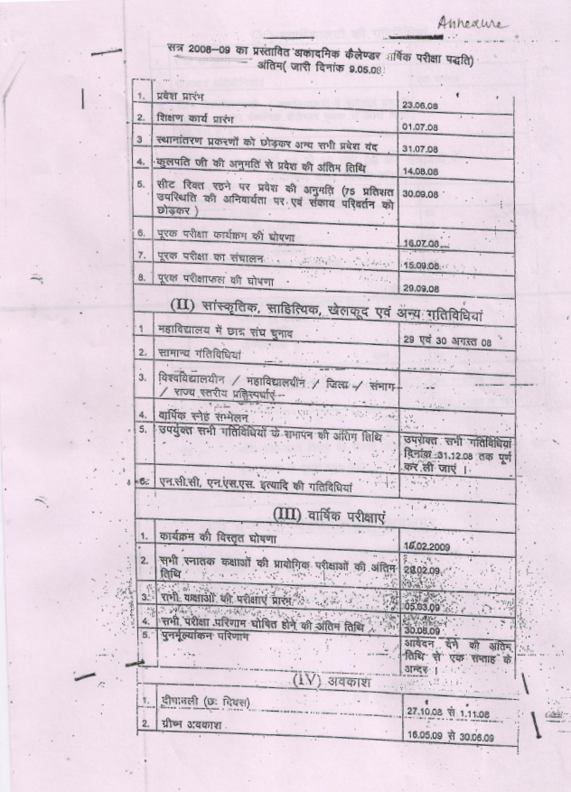

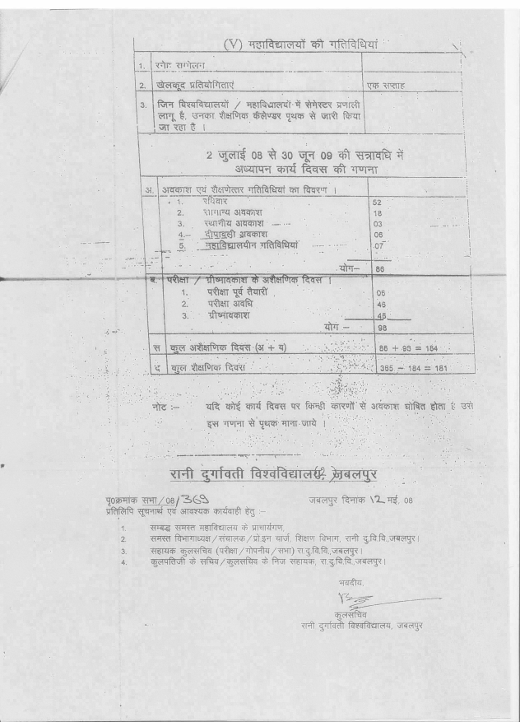

List of the students getting awards
2008-09
- Sports
- Sourabh Raghuwanshi – B.C.A III - Table tennis and Badminton
- Ram Krishan Rajak - B.A. I - Badminton
- Rajesh Chouksey - M.Com Final - Cricket

- On-Merits
5 Students were awarded On- Merits.

- Cultural Events
a. Alfaf Behna - B.A. I
b. Anjali Rawat - B.A I
c. Divya Pathak - B.Sc. III

List of the Girls students getting Scholarship
On the memory of smt. Icharaj Bai
2008-09

- Ku. Gayatri Gound - B.A. I - Rs. 1000/-
- Ku. Jyoti Pastariya - B.A. I - Rs. 1000/-
- Ku. Arti Namdeo - B.A. I - Rs. 1000/-
- Ku. Shilpi Verma - B.Sc. II - Rs. 1000/-
- Ku. Jyoti Vishwakarma - B.Sc. III - Rs. 1000/-

