The Annual Quality Assurance Report (AQAR)
of the IQAC – Year 2017-18

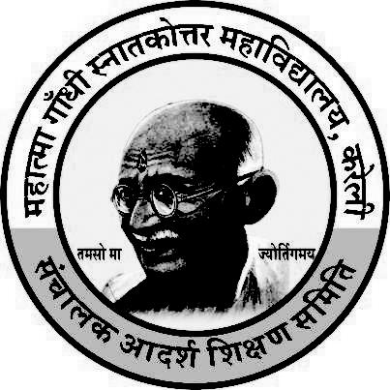

Track ID - MPCOGN13466
Submitted by
IQAC
Mahatma Gandhi Post-Graduate College,
Kareli. Distt. Narsingpur (M.P.)

The Annual Quality Assurance Report (AQAR) of the IQAC

Part – A
1. Details of the Institution
Mahatma Gandhi P.G. College, Kareli
1.1 Name of the Institution
Mahadev Ward
1.2 Address Line 1
Main Road
Address Line 2
Kareli
City/Town
M.P.
State
487221
Pin Code
mgckarnarhe@gmail.com
Institution e-mail address
07793-271566
Contact Nos.
Dr. R.K. Acharya
Name of the Head of the Institution:
07793-271566
Tel. No. with STD Code:
9425635585

Mobile:
Name of the IQAC Co-ordinator:
Dr. A. K. Bajpai

9425304601
Mobile:
mgpgcollegekareli@gmail.com
IQAC e-mail address:

MPCOGN13466
1.3 NAAC Track ID (For ex. MHCOGN 18879)

1.4 NAAC Executive Committee No. & Date:
1 st Cycle - 31 March 2007

(For Example EC/32/A&A/143 dated 3-5-2004.
2 nd Cycle – 11-12-13 December 2014

This EC no. is available in the right corner- bottom
of your institution’s Accreditation Certificate)

www.mgpgcollege.org
1.5 Website address:
http://mgpgcollege.org/document/AQAR2017-18.doc

Web-link of the AQAR:
1.6 Accreditation Details
Sl. No. | Cycle | Grade | CGPA | Year of Accreditation | Validity Period
1 | 1st Cycle | B+ | 76.00 | 2007 | 2012
2 | 2nd Cycle | B | 2.46 | 2015 | 2020
3 | 3rd Cycle | - | - | - | -
4 | 4th Cycle | - | - | - | -

Annexure No. 1 (Accreditation Certificate of 2007)

Annexure No. 2 (Accreditation Certificate of 2015)

1.7 Date of Establishment of IQAC : DD/MM/YYYY
24/07/2008

2017-18
1.8 AQAR for the year (for example 2010-11)
1.9 Details of the previous year’s AQAR submitted to NAAC after the latest Assessment and Accreditation by NAAC ((for example AQAR 2010-11submitted to NAAC on 12-10-2011)
- AQAR of (2012-13) submitted on 09/06/14 Re-submitted Online on 30/06/2015.
- AQAR of (2013-14) submitted on 09/06/14 Re-submitted Online on 30/06/2015.
- AQAR of ( 2014-15) Online submitted on 30/06/2015 (DD/MM/YYYY)
- AQAR of ( 2015-16) Online submitted on 30/06/2016 (DD/MM/YYYY)
- AQAR of ( 2016-17) Online submitted on 21/07/2017 (DD/MM/YYYY)
- AQAR of ( 2017-18) Online submitted on 30/07/2018 (DD/MM/YYYY)
1.10 Institutional Status
\\\\\\\

University State Central Deemed Private


Affiliated College Yes No
Constituent College Yes No

Autonomous college of UGC Yes No

Regulatory Agency approved Institution Yes No
(eg. AICTE, BCI, MCI, PCI, NCI)


Type of Institution Co-education Men Women


Urban Rural Tribal







Financial Status Grant-in-aid UGC 2(f) UGC 12B

Grant-in-aid + Self Financing Totally Self-financing



1.11 Type of Faculty/Programme


Arts Science Commerce Law PEI (Phys Edu)




TEI (Edu) Engineering Health Science Management

B.J.C., B.C.A.
Others (Specify)
Rani Durgavati Vishwavidyalaya Jabalpur (M.P.)
1.12 Name of the Affiliating University (for the Colleges)
1.13 Special status conferred by Central/ State Government-- UGC/CSIR/DST/DBT/ICMR etc

Autonomy by State/Central Govt. / University

University with Potential for Excellence UGC-CPE

DST Star Scheme UGC-CE

UGC-Special Assistance Programme DST-FIST

UGC-Innovative PG programmes Any other (Specify)

UGC-COP Programmes
2. IQAC Composition and Activities
05
2.1 No. of Teachers
02
2.2 No. of Administrative/Technical staff
02
2.3 No. of students
2.4 No. of Management representatives
02
02
2.5 No. of Alumni
2. 6 No. of any other stakeholder and
01
community representatives
01
2.7 No. of Employers/ Industrialists
01
2.8 No. of other External Experts
16
2.9 Total No. of members
2.10 No. of IQAC meetings held
03
01
Commerce
2.11 No. of meetings with various stakeholders: No. Faculty
01 02
01
01
Non-Teaching Staff Students Alumni Others


2.12 Has IQAC received any funding from UGC during the year? Yes No

If yes, mention the amount Rs. 300000/- was recd. In the year 2013-14
2.13 Seminars and Conferences (only quality related)
(i) No. of Seminars/Conferences/ Workshops/Symposia organized by the IQAC
02
0
0
0
02
Total Nos. International National State Institution Level
- B.J.C. – News (Fake/True) and Social Media.
- Commerce – Impact of Government Policies in Agricultural Development

(ii) Themes

2.14 Significant Activities and contributions made by IQAC
1. Documentation of Records and Reports.
2. Computer training programme for teaching and non-teaching.
3. Participation in Swachha Bharat Abhiyan Programmes.
4. Seminar on Cashless Payment.
2.15 Plan of Action by IQAC/Outcome
The plan of action chalked out by the IQAC in the beginning of the year towards quality
enhancement and the outcome achieved by the end of the year *
Plan of Action | Achievements and Outcome at the end of Session
• Guest Lecture will be organized in different Departments. | - Guest Lectures are organized  in different Departments.
- Celebration of important days of the year ( Environment day, Hindi day, Science day Gandhi Jaynti etc.) | - World AIDS day,  Environment day, Hindi day and Science day Independence day, Teachers Day Gandhi Jayanti, and Republic day were celebrated.
- Alumni association meet & parent teacher meet to be continued. | - Alumni, parent teacher meetings and health check up camps were  organized. Drinking water utensils (glasses + steel small reservoir for water) was given to the college by Alumni association. Water cooler of about Rs. 25000/- was also given to the college for students.
- New Books for library will be procured. | - New Books for library have been purchased.
- Healthy practices will be continued. | - Healthy practices were  continued.
- To conduct seminars for PG students to develop presentation skills. | - Seminars for PG students were  conducted to develop  presentation skills.
- To carry out B.J.C. students dissertation and job oriented projects. | - B.J.C. students carried out  dissertation and job oriented  projects
- To organize carrier guidance lectures and campus selection. | - Lectures were organized and campus selection drive was organized
- Old Administrative Building Construction. | - Old Administrative Building  is in dilapidated condition so in  this place new construction for  the class rooms will be carried out
- Regularity in classes and emphasis on completion on syllabi. | - Regularity in classes is  maintained, syllabi is completed.
- To follow the academic calendar of University. | - Academic calendar of University  was followed
- To conduct cultural programme and sports for students. | - Cultural programme and sports  for students were conducted
- Proposal to begin PG Classes in Zoology, Chemistry, Physics in Science Faculty and M.A. in Political Science in Arts Faculty | - PG Classes in Zoology,  Chemistry, Physics in Science  Faculty and M.A. in Political  Science in Arts Faculty started  from July 2018.
* Attach the Academic Calendar of the year as Annexure. Annexure No. 2


2.15 Whether the AQAR was placed in statutory body Yes No



Management Syndicate Any other body
Provide the details of the action taken
- Recommendation for early declaration of the results were sent to Registrar of university
- The Plans of IQAC were carried out.

Part – B
Criterion – I

1. Curricular Aspects

1.1 Details about Academic Programmes
Level of the Programme | Number of existing Programmes | Number of programmes added during the year | Number of self-financing programmes | Number of value added / Career Oriented programmes
PhD | Nil | Nil | Nil | Nil
PG | 02 – M.A. (Eco.)  M.Com. | Nil | Nil | Nil
UG | 1. B.A.  2. B.Com(Plain)  3. B.Com(Computer)  4. B.Sc. (Maths)  5. B.Sc. (Bio)  6. B.Sc. (C.S.)  7. B.Sc. (C.A.)  8. B.Sc. (Micro)  9. B.J.C.  10. B.C.A. | Nil | 1. B.Com.(Comp.Appl.)  2.B.Sc.(Microbiology)  3. B.Sc. (Comp. Sc.)  4. B.Sc. (Comp. Appl.)  5. B.C.A.  6. B.J.C. | Nil
PG Diploma | Nil | Nil | Nil | Nil
Advanced Diploma | Nil | Nil | Nil | Nil
Diploma | Nil | Nil | Nil | Nil
Certificate | Nil | Nil | Nil | Nil
Others | Nil | Nil | Nil | Nil
Total | 12 | Nil | 06 | Nil

Interdisciplinary | - | - | - | -
Innovative | - | - | - | -

1.2 (i) Flexibility of the Curriculum: CBCS/Core/Elective option / Open options
(ii) Pattern of programmes:
Pattern | Number of programmes
Semester | P.G. – M.A. (Eco.), M.Com = 02  PG in Zoology, Chemistry, Physics from July 2018 and PG in Political Science started from July 2018  UG –  1. B.A.  2. B.Com(Plain)  3. B.Com(Computer)  4. B.Sc. (Maths)  5. B.Sc. (Bio)  6. B.Sc. (C.S.)  7. B.Sc. (C.A.)  8. B.Sc. (Micro)  9. B.C.A.  UG Geography and Computer Application Subjects started from July 2018
Trimester | Nil
Annual | 01 (B.J.C.)








1.3 Feedback from stakeholders* Alumni Parents Employers Students
(On all aspects)




Mode of feedback : Online Manual Co-operating schools (for PEI)
*Please provide an analysis of the feedback in the Annexure

1.4 Whether there is any revision/update of regulation or syllabi, if yes, mention their salient aspects.
The College follows the rules and Directions of Higher Education Government of M.P. and Rani Durgavati Vishwavidyalaya , Jabalpur to which it is affiliated. As semester system was introduced in 2008 so there was change in syllabi and it was moderated in 2009-10. Further Syllabi was again moderated in the year 2012-13 and 2014-15. Yearly Pattern examination is introduced form the 1st Year for the students admitted in July 2017-18 and syllabi is moderated in the year 2017-18. P.G. in Zoology, Chemistry, Physics in Science Faculty and P.G. in Political Science from July 2018 and in UG Geography, Computer Application in Arts Faculty as subjects to be started from July 2018. The College has no autonomy to change the syllabi.

1.5 Any new Department/Centre introduced during the year. If yes, give details.
Nil

Criterion – II
2. Teaching, Learning and Evaluation
2.1 Total No. of permanent faculty
Total | Asst. Professors | Associate Professors | Professors | Others
20 | 07 | - | 01 | 12
07
2.2 No. of permanent faculty with Ph.D.
2.3 No. of Faculty Positions Recruited (R) and Vacant (V) during the year 2015-16
Asst. Professors |  | Associate Professors |  | Professors |  | Others Sports off. And Librarian |  | Others 3rd and 4th class employee |  | Total
R | V | R | V | R | V | R | V | R | V | R | V
Nil | 04 | - | - | 00 | 01 | - | 02 | 00 | 05 | Nil | 12
(Permanent Employees)
---
---
12
2.4 No. of Guest and Visiting faculty and Temporary faculty
2.5 Faculty participation in conferences and symposia:

No. of Faculty | International level | National level | State level
Attended Seminars/ Workshops | Nil | 05
Presented papers | Nil | 04
Resource Persons | Nil | 02

2.6 Innovative processes adopted by the institution in Teaching and Learning:
Some of the Lessons Teaching Through Slide Projector and Questioner Methods.

1st Year – 185 (Total days) Actual Teaching Days - 144
3rd & 4th sem – 184 (Total days) Actual Teaching Days – 147
5th & 6th sem – 181 (Total days) Actual Teaching Days – 143
2.7 Total No. of actual teaching days
during this academic year
2.8 Examination/ Evaluation Reforms initiated by
As the college is affiliated to Rani Durgavati Vishwavidyalaya Jabalpur So it has to follow Examination pattern of University.
the Institution (for example: Open Book Examination, Bar Coding,
Double Valuation, Photocopy, Online Multiple Choice Questions)

2.9 No. of faculty members involved in curriculum
01
01
01
restructuring/revision/syllabus development
as member of Board of Study/Faculty/Curriculum Development workshop
2.10 Average percentage of attendance of students
87 %

2.11 Course/Programme wise
distribution of pass percentage :
Session - 2017-18
Title of the Programme | Total no. of students appeared | Division
Title of the Programme | Total no. of students appeared | Distinction % | I % | II % |  | III % | Pass %
B.A. VI sem | 159 | 40 | 68 | 72 |  | 18 | 158
B.Sc. VI sem | 110 | 31 | 63 | 26 |  | 17 | 106
B.Com VI sem | 113 | 43 | 57 | 35 |  | 20 | 112
B.C.A. VI sem | - | - | - |  | - | - | -
M.A. IV sem | - | - | - |  | - | - | -
M.Com. IV sem | 28 | Result Not Declared
B.J.C. | 06 |  | - |  | 2 | 2 | 4
2.12 How does IQAC Contribute/Monitor/Evaluate the Teaching & Learning processes:
- By taking feedback from the students and having discussion with teachers and parents.
- By implementing the suggestions received.
2.13 Initiatives undertaken towards faculty development
Faculty / Staff Development Programmes | Number of faculty  benefitted
Refresher courses | -
UGC – Faculty Improvement Programme | -
HRD programmes | -
Orientation programmes | -
Faculty exchange programme | -
Staff training conducted by the university | 1
Staff training conducted by other institutions | 1
Summer / Winter schools, Workshops  etc. | 6
Others | -
2.14 Details of Administrative and Technical staff
Category | Number of Permanent  Employees | Number of Vacant  Positions | Number of permanent positions filled during the Year | Number of positions filled temporarily
Administrative Staff | 02 | 02 | Nil | 05
Technical Staff | Nil | Nil | Nil | Nil
Criterion – III
3. Research, Consultancy and Extension
3.1 Initiatives of the IQAC in Sensitizing/Promoting Research Climate in the institution
The college is not research centre yet two teachers of the college are guiding research scholars one each in commerce and sociology.

3.2 Details regarding major projects
 | Completed | Ongoing | Sanctioned | Submitted
Number | Nil | Nil | Nil | Nil
Outlay in Rs. Lakhs | - | - | - | -

3.3 Details regarding minor projects
 | Completed | Ongoing | Sanctioned | Submitted
Number | Nil | 02 | 02 | Nil
 | Title – Commercial Development and Water Resource Management in Narsinghpur Distt of (MP) |  | UGC CRO Bhopal Letter No. FNo: MH-145/ 106044/ XII/14-15/ CRO Dated 03-03-15 – Allocated Amount - 300000/-  Released Amount - 210000/-  submitted | Letter of Sanction is Received
 | Title – Rural Women Leadership and Social Change in Tribal Areas of Balaghat Distt – M.P. |  | UGC CRO Bhopal Letter No. FNo: MH-70/106044/XII/14-15/ CRO Dated 03-03-15  Allocated Amount 2,60,000/-  Released Amount – 167500/-  submitted | Letter of Sanction is Received

3.4 Details on research publications
 | International | National | Others
Peer Review Journals | - | - | -
Non-Peer Review Journals | - | - | -
e-Journals | - | - | -
Conference proceedings | - | 11 | -

3.5 Details on Impact factor of publications:

Range Average h-index Nos. in SCOPUS
3.6 Research funds sanctioned and received from various funding agencies, industry and other organisations
Nature of the Project | Duration  Year | Name of the  funding Agency | Total grant  sanctioned | Received
Major projects | - | - | - | -
Minor Projects |  | UGC CRO Bhopal Letter No. FNo: MH-145/ 106044/ XII/14-15/ CRO Dated 03-03-15  submitted | Allocated Rs.  300000/-  Released  210000/- | Letter of Sanction is Received
Minor Projects |  | UGC CRO Bhopal Letter No. FNo: MH-70/106044/XII/14-15/ CRO Dated 03-03-15  submitted | Allocated  2,60,000/-  Released  167500/- | Letter of Sanction is Received
Interdisciplinary Projects | - | - | - | -
Industry sponsored | - | - | - | -
Projects sponsored by the University/ College | - | - | - | -
Students research projects  (other than compulsory by the University) | - | - | - | -
Any other(Specify) | - | - | - | -
Total | - | - | - | -

3.7 No. of books published i) With ISBN No. Chapters in Edited Books
-
Nil
-
ii) Without ISBN No.
3.8 No. of University Departments receiving funds from
UGC-SAP CAS DST-FIST
-
-
-
-
-
DPE DBT Scheme/funds
3.9 For colleges Autonomy CPE DBT Star Scheme
Nil Nil
Nil
Nil
INSPIRE CE Any Other (specify)
-
Nil
Nil
Nil
3.10 Revenue generated through consultancy
Level | International | National | State | University | College
Number | - |  | - | - | 05
Sponsoring agencies | - |  | - | - | College itself
3.11 No. of conferences
organized by the Institution
02
3.12 No. of faculty served as experts, chairpersons or resource persons
Nil
Nil
-
3.13 No. of collaborations International National Any other
Nil
3.14 No. of linkages created during this year
3.15 Total budget for research for current year in lakhs: The college is not research centre so the college has not received any research grant. Yet the teachers who are pursuing minor research project, they have received amount from U.G.C. CRO Bhopal.
From Funding agency From Management of University/College
-
-
Total
-
3.16 No. of patents received this year
Type of Patent |  | Number
National | Applied | Nil
National | Granted | Nil
International | Applied | Nil
International | Granted | Nil
Commercialised | Applied | Nil
Commercialised | Granted | Nil

3.17 No. of research awards/ recognitions received by faculty and research fellows
Of the institute in the year
Total | International | National | State | University | Dist | College
Nil | Nil | Nil | Nil | Nil | Nil | Nil

3.18 No. of faculty from the Institution
02
who are Ph. D. Guides
and students registered under them
12

3.19 No. of Ph.D. awarded by faculty from the Institution
Nil

3.20 No. of Research scholars receiving the Fellowships (Newly enrolled + existing ones)
Nil
Nil

JRF SRF Project Fellows Any other
Nil

Nil

3.21 No. of students Participated in NSS events:
Nil

Nil
University level State level
National level International level
Nil
Nil

3.22 No. of students participated in NCC events:
Nil

Nil

University level State level
National level International level
Nil
Nil

3.23 No. of Awards won in NSS:
02

University level State level
Nil

National level International level
Nil

Nil

3.24 No. of Awards won in NCC:
University level State level
Nil

Nil

National level International level
Nil

Nil

3.25 No. of Extension activities organized
Nil

02

University forum College forum
04
05
Nil
NCC NSS Any other
3.26 Major Activities during the year in the sphere of extension activities and Institutional Social Responsibility
- Orientation Programme of NSS 10-11 August 2017.
- Teachers Day celebration 05-09-2017.
- Celebration of NSS Day 24-09-2017.
- Gandhi Jayanti Celebration 02-10-2017. Lecture was organized on Relevance of Gandhi Ji in
21st century.
AIDS awareness programme 01-Dec-2017.
- Blood Donation on death anniversary on S. R. Paliwal 03-01-2018.
- One day seminar by IQAC & Commerce Department, Subject – E Commerce- Internet Banking on February 2018 by Shri Satya Prakash Meena manager of Allhabad Bank Branch Kareli and others.
- Lecture on Empowerment of Women by Monika Shukla Superintendent of Police Dist. Narsinghpur on 13-10-2017.
- Celebration of Swami Vivekanand Jayanti on 12-Jan-2018.
- Awareness programme for young voters specially on voters day 25-01-2018.
- Cleansing of College Campus Area and removal of Polythene bags from the adjoining area on Republic day – 26-Jan-2018.
- Rally organized by N.C.C. Cadets on Water Conservation.
- Celebration Basant Panchami on 01-Feb-2018
- NSS Camp by M.G.P.G. College Unit at Rankai Pipariya (Th. Kareli) on 03-02-2018 to
09-02-2018.
- Digital Workshop on BHIM App organized on 23-Feb-2018 by N.C.C.
- One day seminar by IQAC & BJC – Role of Social Media in making people environmentally aware of MP. February 2018.
- One day workshop on Make in India and entrepreneurship by Dept. of Commerce on 03-03-2017.
- Participation of NSS unit on District Level Camp at Amgaonbada Dist. Narsinghpur 30-03-2017 to 05-04-2017.
- Summer Internship under clean India programme at Rankai Pipariya by N.C.C. Cadets.
- Awareness Programme on Clean Village at Rankai Pipariya by N.C.C. Cadets
- Plantation programme by N.C.C. Cadets on 5th June 2018 Word Environment Day at field
adjacent to college play ground.
- Celebration of Yoga Diwas at College on the occasion of International Yoga Day – 21-June-
- 2018 is celebrated.
- Celebration of International Rehabilatation Day on 26-Jun-2018.
- 161 Candidates are selected for security guards/officers during the campus selection organized by Viveknand Carrier Guidance Cell on 04-05-July-2018 at MGPG College Kareli. This campus carnival was scheduled to be organized in the first week of June 2018 but due to certain unavoidable circumstances this was extended in the first week of July.

Criterion – IV
4. Infrastructure and Learning Resources
4.1 Details of increase in infrastructure facilities:
Facilities | Existing | Newly created | Source of Fund | Total
Campus area | 04 acres | - | - | -
Class rooms | 30 | Nil | UGC | 30
Laboratories | 07 | - | - | -
Seminar Halls (Auditorium) | 01
Administrative Block |  | 01 | College Fund +UGC
No. of important equipments purchased (≥ 1-0 lakh) during the current year.
Value of the equipment purchased during the year (Rs. in Lakhs) |  | 299173/- | UGC + College Sources | -
Others

4.2 Computerization of administration and library
Administrative work is partially computerized.
Library is partially computerized.

4.3 Library services:
 | Existing |  | Newly added |  | Total
 | No. | Value | No. | Value | No. | Value
Text Books | 27296 | 2718238 | 823 | 201810 | 28119 | 2920048
Reference Books | 98 | 25635 | 98 | 130738 | 196 | 156373
e-Books | Nil | Nil | Nil | Nil | Nil | Nil
Journals | 115 | 44645 | 11 | 4130 | 126 | 48775
e-Journals | Nil | Nil | Nil | Nil | Nil | Nil
Digital Database | Nil | Nil | Nil | Nil | Nil | Nil
CD & Video | 11 | 1708 | Nil | Nil | 11 | 1708
Others (specify) | 173 | 26701 | Nil | Nil | 173 | 26701
4.4 Technology up gradation (overall)
 | Total Computers | Computer Labs | Internet | Browsing Centres | Computer Centres | Office | Depart-ments | Others
Existing | 81 | 02 | 10 | 02 | - | 01 | 01 | Smart Class+ ICC Room
Added
Total | 81 | 02 | 10 | 02 | - | 01 | 01
4.5 Computer, Internet access, training to teachers and students and any other programme for technology
upgradation (Networking, e-Governance etc.)
- Computer training programme was organized for teaching and non-teaching staff of the college.
- Workshop on Internet Banking was organized for teaching and non teaching staff of the college.

4.6 Amount spent on maintenance in lakhs :
34225/-
i) ICT
1636920/-
ii) Campus Infrastructure and facilities
& Constructionof Building
299173/- (UGC – 255635+ College 43538)
iii) Equipments (UGC+College)

733469/-
iv) Others

2703787/-
Total :

Criterion – V
5. Student Support and Progression
5.1 Contribution of IQAC in enhancing awareness about Student Support Services
The college Publishes its updated prospectors and provides all the necessary information about the college. The slow learners coming from rural areas are identified and important notes and study metrical is provided to them.

5.2 Efforts made by the institution for tracking the progression
- Library facilities.
- Laboratories up-to-date.

5.3 (a) Total Number of students
UG | PG | Ph. D. | Others
1256 | 62 | Nil | Nil

(b) No. of students outside the state
Nil
Nil
(c) No. of international students

Men Women
No | %
- | -
No | %
- | -
2015-16 |  |  |  |  |  | 2016-17
General | SC | ST | OBC | Physically Challenged | Total | General | SC | ST | OBC | Physically Challenged | Total
441 | 149 | 66 | 656 | 01 | 1313 | 443 | 144 | 63 | 668 | 1 | 1318
Demand ratio – 1.9 Dropout % - 2.75%
5.4 Details of student support mechanism for coaching for competitive examinations (If any)
Nil
Nil
No. of students beneficiaries

5.5 No. of students qualified in these examinations
-
-
-
-
NET SET/SLET GATE CAT
IAS/IPS etc State PSC UPSC Others
-
-
-
12
The students who qualify NET and SET/SLET etc. do not inform so the numbers are not available.

5.6 Details of student counselling and career guidance
60

50
No. of students benefitted

5.7 Details of campus placement
On campus |  |  | Off Campus
Number of Organizations Visited | Number of Students Participated | Number of Students Placed | Number of Students Placed
02 | 105 | 48 (Selected) | 06

5.8 Details of gender sensitization programmes
Role of Women in Local Body Administration

5.9 Students Activities
5.9.1 No. of students participated in Sports, Games and other events
06l
Nil
Nil
State/ University level National level International level

No. of students participated in cultural events
-
Nil
Nil
State/ University level National level International level

5.9.2 No. of medals /awards won by students in Sports, Games and other events
Nil

Nil

01
Sports : State/ University level National level International level
Nil

Nil

Nil

Cultural: State/ University level National level International level

5.10 Scholarships and Financial Support
 | Number of  students | Amount
Financial support from institution | - | -
Financial support from government  There include Post Metric, Gaon ki Beti, Pratibha Kiran, Karmakar Mandal, M.M.V.Y., Vikramiditya Yojna  (Scholarship of some students came late) | 1147 | 7344115/-  This amount is sent to the Government as a Proposal for the Various Scholarships and the amount of scholarship is deposited directly on their accounts
Financial support from other sources | - | -
Number of students who received International/ National recognitions | - | -

5.11 Student organised / initiatives
Nil
Nil
Nil
Fairs : State/ University level National level International level
NIl
Nil
Nil
Exhibition: State/ University level National level International level
02
5.12 No. of social initiatives undertaken by the students

5.13 Major grievances of students (if any) redressed:
1. Like previous year there was delay in the declaration of results of the university this year too and
complaint was received from the Students to college in this regard and the principal of the college in
consultation with the teachers of the college wrote a letter to Registrar of R.D.V.V. Jabalpur for early
declaration of the students.
2. The students made request for the stoppage of auto/taxi etc. at the college gate.

Criterion – VI
6. Governance, Leadership and Management
6.1 State the Vision and Mission of the institution
The vision and objectives of the institution are as follows :
- To provide facilities to achieve excellence in Higher Education to talented students of the state.
- To bring about qualitative up gradation and to equip the students to face the economic and technical challenges despite living in a small town.
- To enhance the spirit of nationality, national integrity and inculcate high moral values.
- To develop social concern and civil responsibilities among the upcoming talented youth
- To provide guidance for competitive examinations and ensure all-round personality development
- To provide career guidance, promote computer skills, communicative skills, extempore presentation and inculcate reading habits.
- To promote all-round personality development of the students.

6.2 Does the Institution has a management Information System
Yes the Institution has a management Information System.

6.3 Quality improvement strategies adopted by the institution for each of the following:
6.3.1 Curriculum Development
- Since 2008-09 semester system has been introduced in all programmes of UG/PG by the MP State Government and Rani Durgavati Vishwa Vidyalaya Jabalpur (M.P.) to which the college has been affiliated. Syllabi was Moderated in 2009-10 and it was Further moderated in the years 2012-13, and 2014-15. Since yearly system of examination for 1st year students is implemented by government from July 2017 so syllabi is moderated The College has no Autonomy to Changer or moderate the syllabi.
- All the UG student of the college are provided computer knowledge (theoretical and practical) as part of the Foundation Courses in UG semesters V and VI, which is compulsory to all UG Students.

6.3.2 Teaching and Learning
Academic Calendar is provided by the Rani Durgavati Vishwavidyalaya Jabalpur and M.P. Higher Education Department at the beginning of each academic session, according to which teachers prepare Teaching Plan. The lecture method of teaching is the general method of teaching. However it is supplemented with Power Point presentation, LCD slides, OHP, computer-assisted learning, seminars, compulsory projects/internship, group task etc. Evaluation is done in the form of CCE and project work as per the schedule provided by the M.P. Higher Education Department. Internship of two months is compulsory for all UG Sem VI and PG Sem IV students.

6.3.3 Examination and Evaluation
Since the Government has introduced semester system in the college, there is process of CCE (internal examination) and main written examination conducted by university. The state government has made CCEs mandatory in all the colleges, in which each student has to be evaluated in each semester. The evaluation methods are communicated to the students in the classroom and through information pasted on the notice board. The institution monitors the progress of the students through CCE and the students are informed about their performance. Marks of CCEs are displayed on the notice board. Even be yearly system of examination is introduced sicne 2017 July CCE is made compulsory

6.3.4 Research and Development
Though the college is not center for research, yet two teachers of the college are guiding research scholars There is a Research Committee to facilitate and monitor research activity. Registered guides for Ph.D. and some other Asst. Professors are members of this committee. The committee regulates and promotes research activities by encouraging projects to get research grants. Meetings are also conducted from time to time to monitor research progress.
Composition:
            - Dr. U. S. Parmar, Co-ordinator
            - Dr. A. K. Bajpai,, Member
            - Dr. G. N. Mishra , Member
            - Shri. S. K. Beohar, Member

6.3.5 Library, ICT and physical infrastructure / instrumentation

The institution has good library, the books are issued to the students and a record is kept to ensure the

security of the same. A close monitoring and using close access are used and there is Library Advisory

Committee that gives advice to the library as and when necessary. There are the various support

facilities available in the library. The books in the library are purchased as are recommended by Heads

of the Departments according to State Government rules, who ensure purchase and use of current

titles, important journals and other reading materials. The institution has up-to-date computer

facilities. There is NRC in the college which the students as well as staff can use. The institution has its

on website www.mgpgcollege.org and it is updated as and when the need arises. The institution

upgrades its computer systems according to the student strength and necessity. Governing body of the

college sanctions purchase of computers for self-financing courses. The curriculum also caters the

inclusion/integration of Information and communication Technology (ITC) for equipping the students

to compete in the global employment markets. All Bachelor degree students have to compulsorily take

Computer Awareness paper in Sem V as a part of Foundation Course. Besides it, computer skills

based self-financing courses are run at the UG.

6.3.6 Human Resource Management
The management and the principal together recruit and monitor personnel required at
all levels. They also ensure that stipulated norms are adhered to. Appraisal and self
appraisal is practised.

6.3.7 Faculty and Staff recruitment
The institution is private college aided by Government and comes under the category of grant-in-aid. Regular staff is employed by the Higher Education Department Government of M.P. and for self financing courses, teachers are recruited at the college level by the Governing body of the college. The Part-time/adhoc faculty are recruited as per the college code statute 28. Wage revision is done at regular intervals.

6.3.8 Industry Interaction / Collaboration
The institution does not have any collaboration on National and international level yet The college sends its students to several local bodies and institutions for internship. This benefits the students as they get on-site training and this benefits the local bodies, so that they get an opportunity to assess the potential of the internee as their future employee. Several students of the college go to Kareli Sugar Mil and Rice Mill for internship purposes.

6.3.9 Admission of Students
Admission Process in the institution is fair. The institution ensures wide publicity to the admission process through Prospectus, Institutional Website, Advertisement and by giving news in the local newspapers , local TV. channel, by distributing pamphlets and pasting posters in rural areas regarding courses of the college. The list of eligible candidates and the list of cut-off percentage and marks are displayed on the college notice board, so that all the candidates or their parents can see it and raise objections, if any.

6.4 Welfare schemes for
Teaching | Provident Fund, Gratuity, P.F. Loan Facility
Non teaching | Provident Fund Loan Facility
Students | Health Check up, Counselling

There are the Welfare measures for the staff and faculty that include GPF, Pension, loans, study leave for research, part final GPF withdrawal etc. Which are implemented by the Higher Education Department, M.P. Govt. to affect and improve staff well-being, satisfaction and motivation.
Nil
6.5 Total corpus fund generated

6.6 Whether annual financial audit has been done Yes No


6.7 Whether Academic and Administrative Audit (AAA) has been done?
Audit Type | External |  | Internal
Audit Type | Yes/No | Agency | Yes/No | Authority
Academic | Yes | Higher Education Department Govt. of M.P. | Yes | By – Management and Principal
Administrative | Yes | Local Fund Audit Jabalpur (M.P.) | Yes | C.A.

6.8 Does the University/ Autonomous College declares results within 30 days?



For UG Programmes Yes No



For PG Programmes Yes No

6.9 What efforts are made by the University/ Autonomous College for Examination Reforms?
NA

6.10 What efforts are made by the University to promote autonomy in the affiliated/constituent colleges?
NA

6.11 Activities and support from the Alumni Association
Alumni meet are conducted every year and their suggestions are followed. Drinking water utensils (glasses + steel small reservoir for water) was given to the college by Alumni association. Water cooler of about Rs. 25000/- was also given to the college for students.

6.12 Activities and support from the Parent – Teacher Association
- Parent teacher meting are conducted and feedback is taken.

6.13 Development programmes for support staff
- Computer training for teaching and non-teaching staff.
- Work Shop on E Banking

6.14 Initiatives taken by the institution to make the campus eco-friendly
- Special drive to remove polythene bags from the college campus and to discourage the use of polythene bages in personal day to day life.
- To make students aware to save greenery.
- Cleansing of drainage in front of college canteen.
- Tree guards were provided for protecting the newly planted plants.

Criterion – VII
7. Innovations and Best Practices
7.1 Innovations introduced during this academic year which have created a positive impact on the
functioning of the institution. Give details.
- Distribution of study notes to students
- Careful monitoring of attendance of the students.
- Wifi Campus by Jio (Relience)

7.2 Provide the Action Taken Report (ATR) based on the plan of action decided upon at the
beginning of the year
- The Construction of Class Rooms in place of old Administrative Building is about to begin.
- Guest Lectures are organized in different Departments.
- World AIDS day, Environment day, Hindi day and Science day Independence day, Teachers Day Gandhi Jayanti, and Republic day were celebrated.
- Alumni, parent teacher meetings and health check up camps were organized.
- New Books for library have been purchased.
- Healthy practices were continued.
- Seminars for PG students were conducted to develop presentation skills.
- B.J.C. students carried out dissertation and job oriented projects
- Lectures were organized
- Academic calendar of University was followed
- Cultural programme and sports for students were conducted
- Lecture and Training programme on cashless society.
- Blood Donation Camp organized.
- Participation of students on Narmada Samagra Swachha Abhiyan.
- Participation of students in Plantation programme during Swachha Bharat Abhiyan

7.3 Give two Best Practices of the institution (please see the format in the NAAC Self-study Manuals)
- Since this is a government aided private institution, the governance of the institution is carried as per the instruction given by the Higher education Department M.P. Government.
- The college Principal wants to see this college electronically equipped. He has introduced the e-mail and SMS system for inter-staff communication. He has also made a functional website of the college. The college campus is WIFI campus.
- Awards are given to the students for their achievements in cultural activities, sports etc.
- Health check up for the students and staff (Teaching and non-teaching).

- Morning assembly once in fortnight is an important feature which is a subtle manifestation of the collective consciousness and purposeful education of M.G.P.G. College Kareli. In the morning assembly Singing of Vande Matram and Jan Gan Man will be continued.
- Another best Practise of the college “Moulding better citizens “ will also be continued.

*Provide the details in annexure (annexure need to be numbered as i, ii,iii)
7.4 Contribution to environmental awareness / protection
- Students were made aware of the environment and to save water.
- Rain water harvesting plan of new administrative block (80X50) is implemented
- Students were discouraged for use of Plastics.
- Rally was organized to make aware the public about environmental Develoments.



7.5 Whether environmental audit was conducted? Yes No

7.6 Any other relevant information the institution wishes to add. (For example SWOT Analysis)
D - SWOT ANALYSIS OF THE INSTITUTION
STRENGTH
- Dynamic management
- Beautiful campus
- Good library
- Reading room for students and the staff
- Good play ground
- Canteen facility
- Gym facilities
- Sanitation vending machine (pad) for girls students is installed in girls common room.
- Well ventilated classrooms
- Well-equipped laboratories
- Affiliated to Rani Durgavati Vishwavidayalaya, Jabalpur (M.P.)
- 2f and 12B certified by UGC
- Experienced Teaching staff supported by the Non-Teaching crew
- NCC and NSS units
- The college campus is WIFI campus.
WEAKNESS
- No recognized Research Centre
- MoUs are not established with industries and research institutes
OPPORTUNITIES
- To start Research Centre
- To introduce more PG Courses
- To organize more campus interviews
- To establish MoUs with nearby reputed industries and research organizations
- To introduce more short term courses
THREATS
- Globalization and Privatization of Higher Education
- B.J.C., B.C.A. and some other courses are on non-grant basis

8. Plans of institution for next year
- College Bus is proposed only for Girls Students.
- Proposal to begin P.G. classes in some subjects.
- To have Class Rooms in place of old Administrative building.
- To procure slide projector.
- Guest Lecture will be organized in different Departments.
- Celebration of important days of the year ( Environment day, Hindi day, Science day Gandhi Jayanti etc.)
- Alumni association meet & parent teacher meet to be continued.
- New Books for library will be procured.
- Healthy practices will be continued.
- To conduct seminars for PG students to develop presentation skills.
- To carry out B.J.C. students dissertation and job oriented projects.
- To conduct National Seminars as approved by UGC CRO Bhopal.
- To follow the academic calendar of University.
- To conduct cultural programme and sports for students.
- Emphasis shall be given on completion and revision of syllabi and active involvement of students in various activities of the college.
- Orientation/Refresher Courses for Newly appointed teachers.
- To carry work on minor research projects sanctioned by U.G.C. CRO Bhopal (M.P.).

Name - Dr. A. K. bajpai Name – Dr. R. K. Acharya

Signature of the Coordinator, IQAC Signature of the Chairperson, IQAC

_______***_______

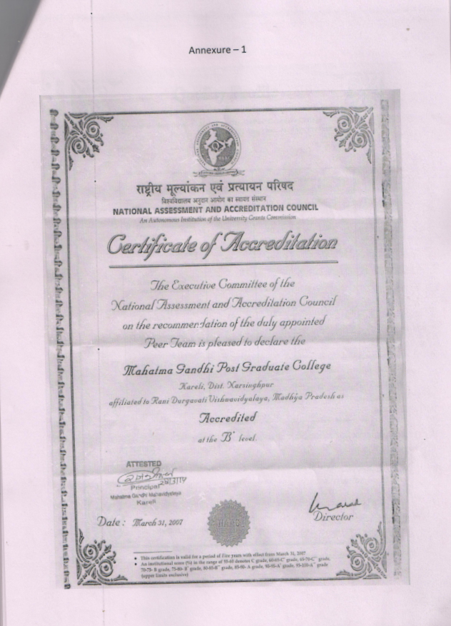

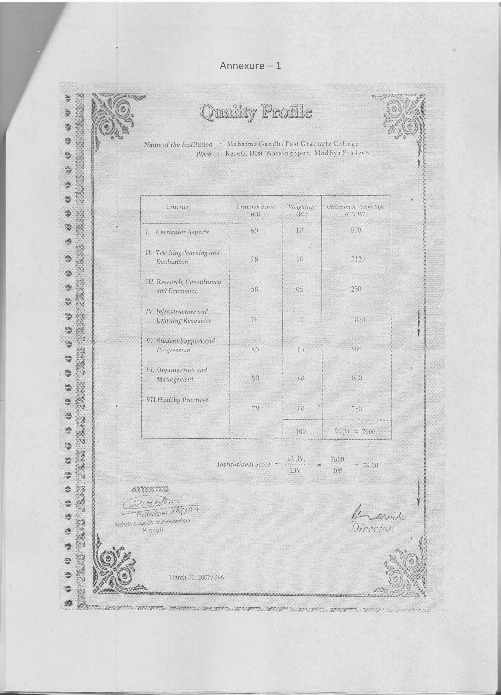

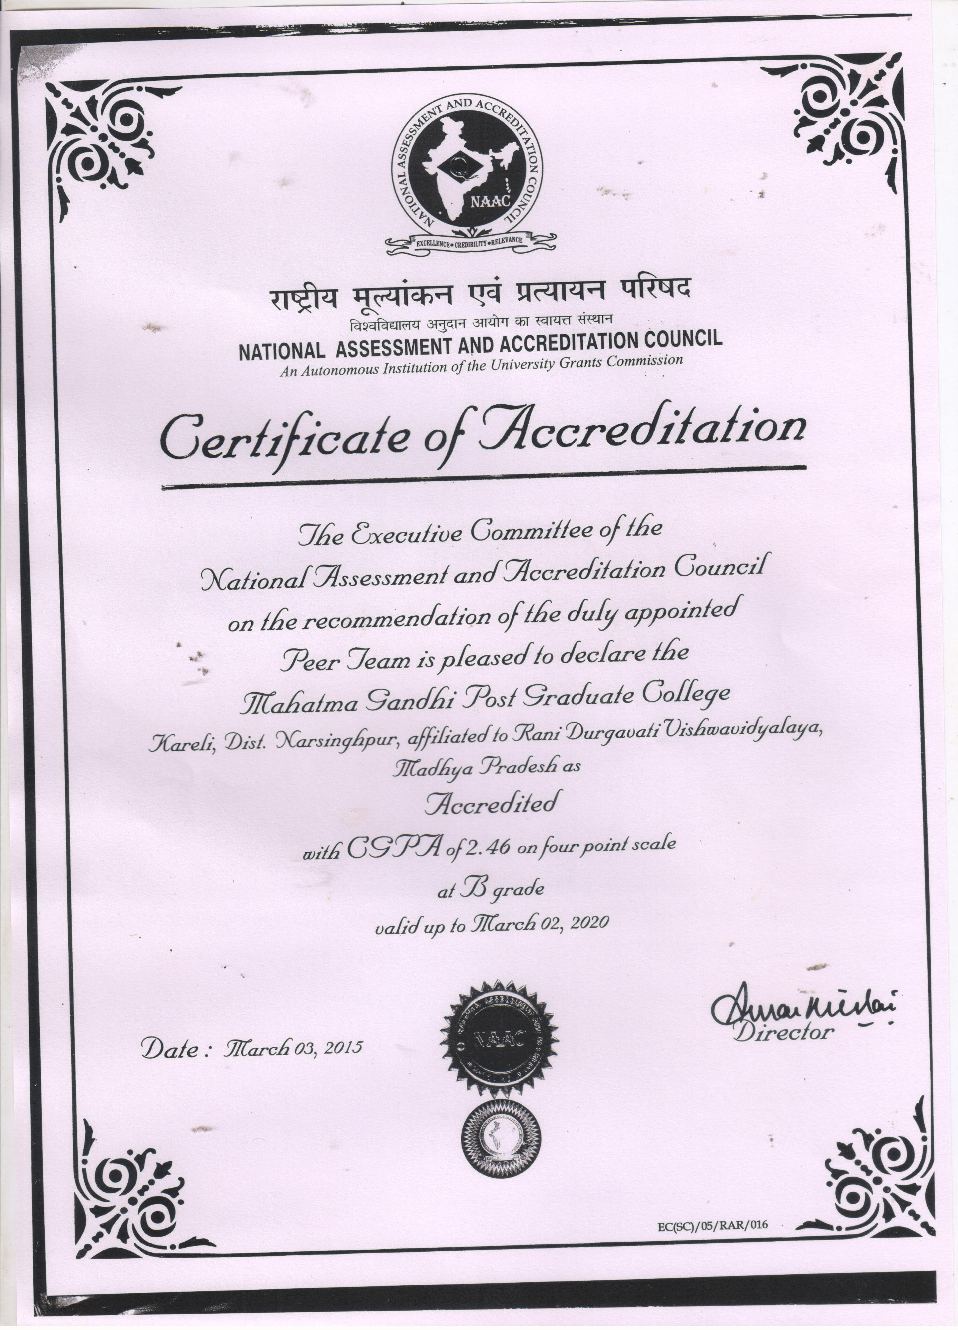

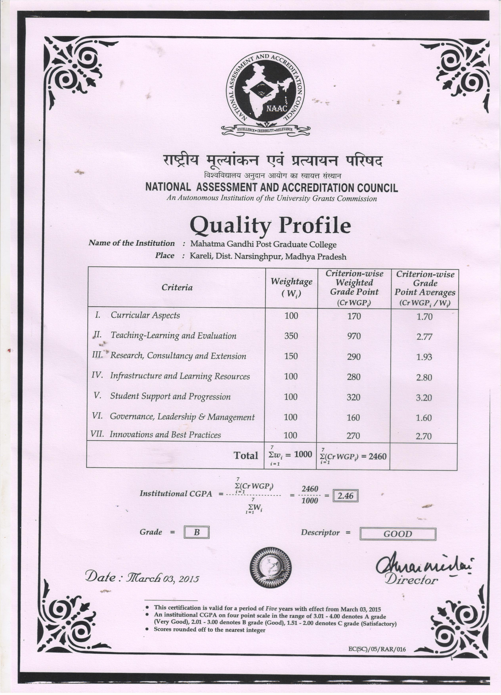

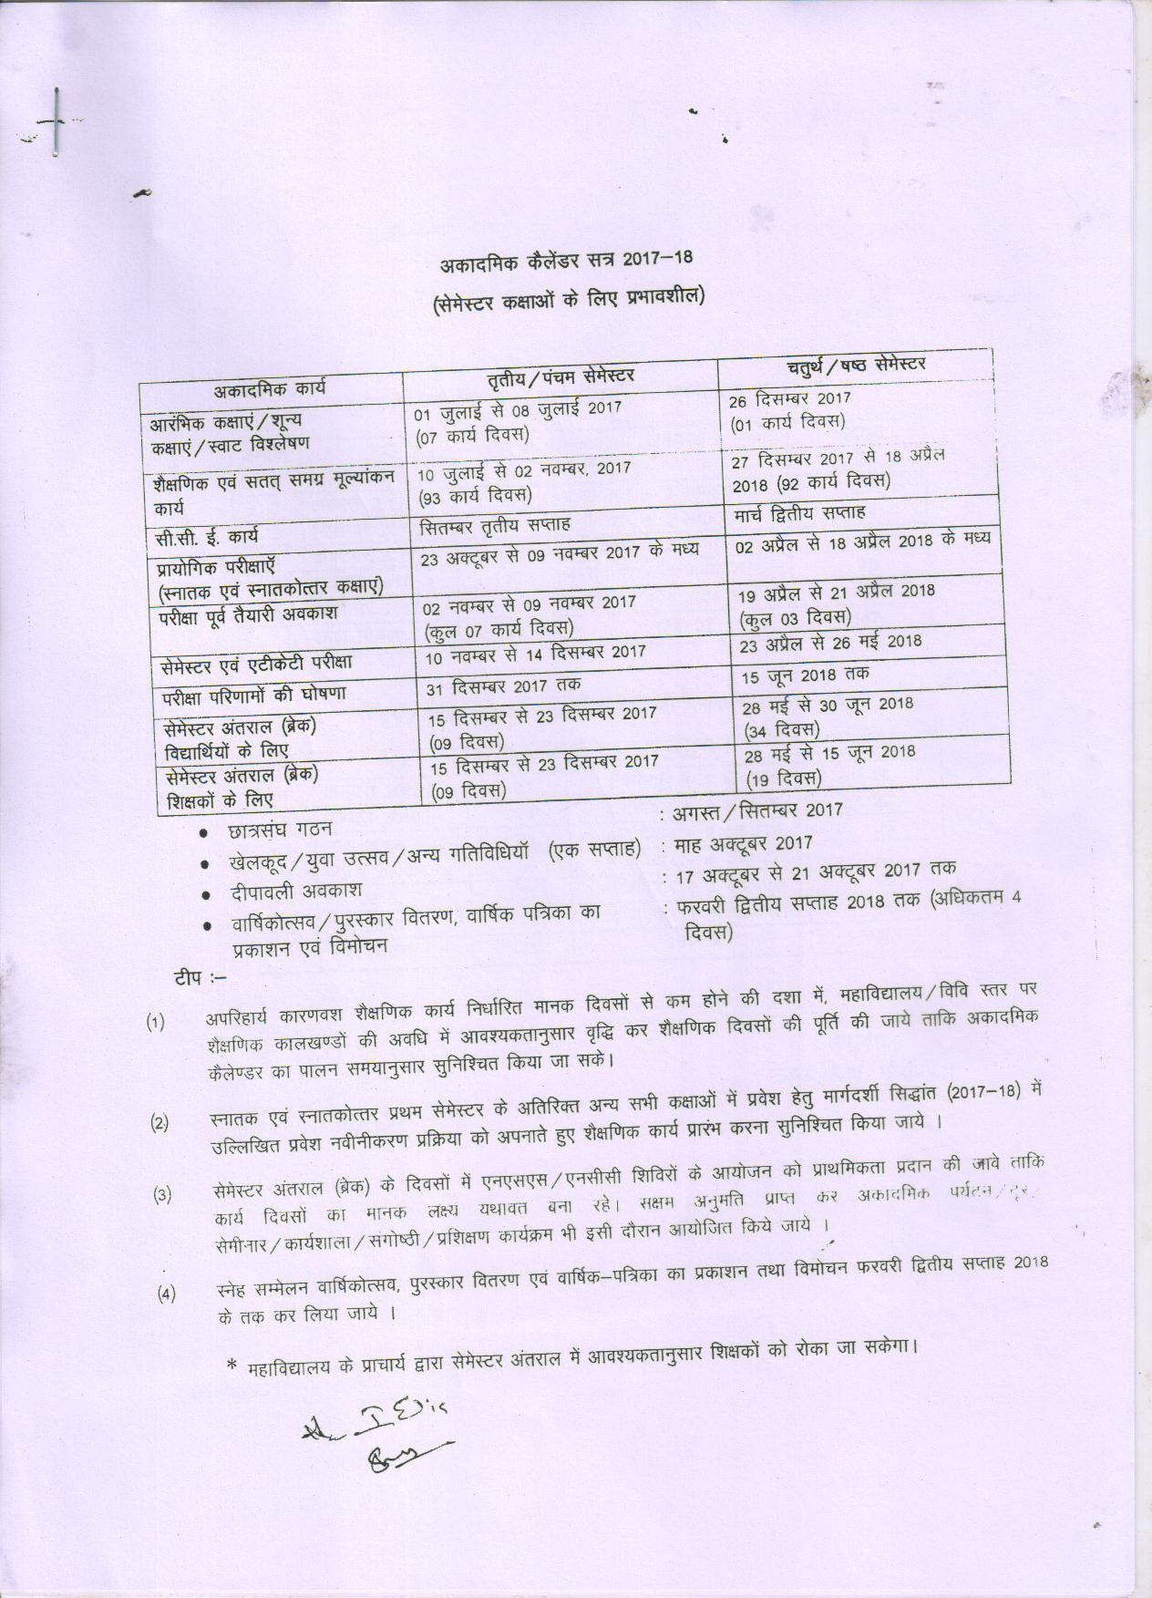
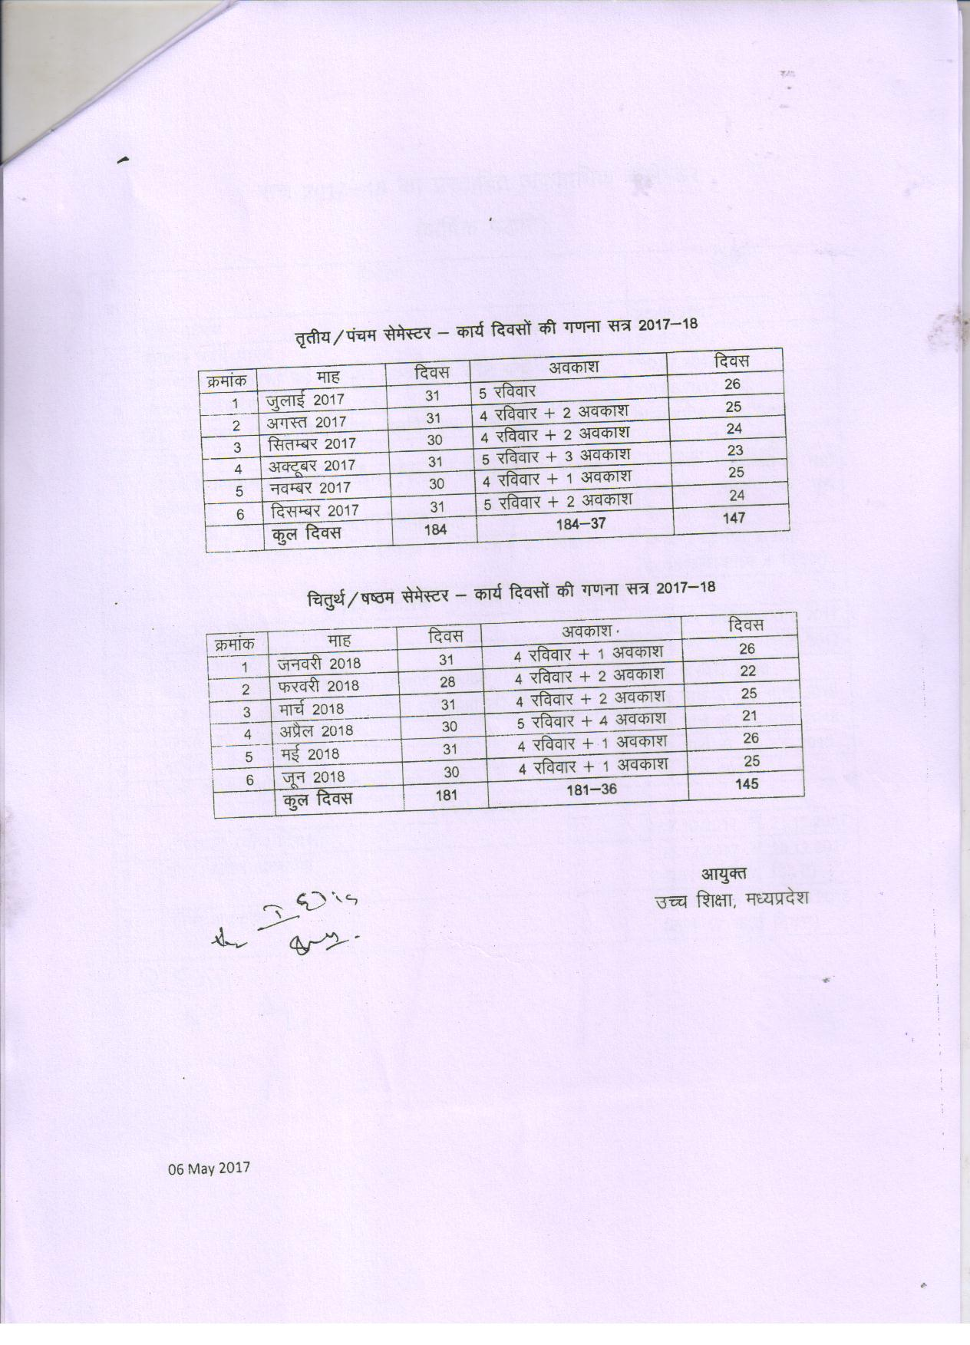
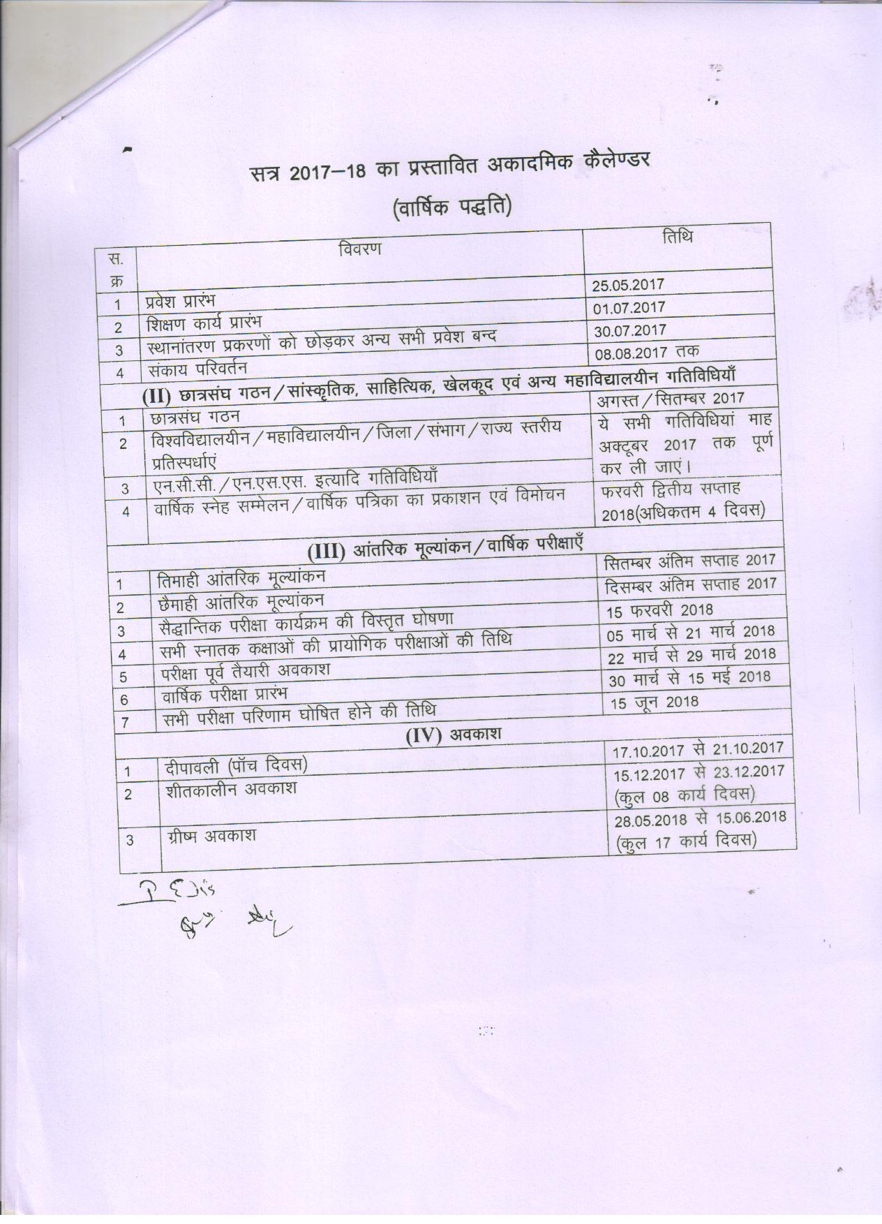
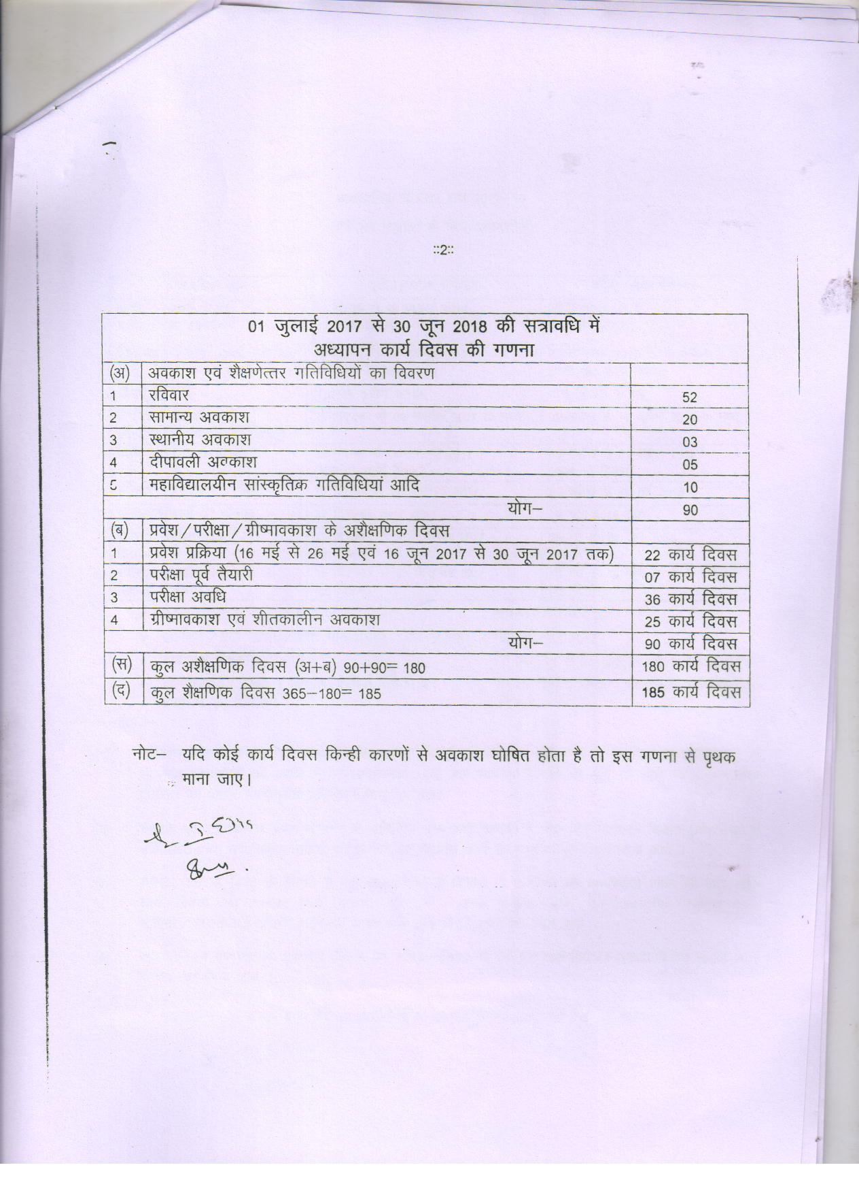
Feedback From stake holders 2017-18
As an instrument of disseminating knowledge in the society Mahatma Gandhi Post Graduate College Kareli Distt. Narsinghpur is aware of its job. An imperative need is felt to establish mechanism regarding feedback from various stack holders so that appropriate steps may be taken regarding the development. The college has obtained feedback through certain established procedures.
- The college is situated in the Narmada belt surrounded by the villages. Feedback from the students and parents suggested for increase in greenery of the college.
- There has been also an emphasis laid by the students obtained in feedback that educational tours should be sent as may increase knowledge of the students.
- Feedback from students, parents and alumni suggested for expedition of results.
- Feedback from parents and alumni suggested for Ban for the use of Polythene bags and prohibition of tobacco chewing in the adjacent area of the college.

Annexure - 5
Human Resource Management – 2017-18
The institute management has made efforts to make administration staff computer literate. Emphasis in also made on E-Commerce & E-Payment Administrative work is computerized. All the information regarding students and staff are available on the click of mouse. This also leads to minimum use of paper in administration. As online admission is continued. This will also help in attaining the aim of paper less administration.
The problem that is faced in this practice is lack of awareness about computer in remote village areas from where the students come. Apart from this failure of electricity and due to some technical reasons down of the server hampers the work.
Various programmes are organized to make the students aware about environment.

Annexure – 5 (B)
List of the students getting awards
2017-18
- Games & Sports

  - Shahjad Khan B.A. IV sem Cricket
  - Suraj Kewat B.Com Ist Year Cricket
  - Arif Khan B.Com Ist Year Cricket
  - Sumit Raikwar B.Com VI sem Badminton
  - Ku. Neha Vishwakarma B.Sc. IV sem Badminton
  - Aashik Ali M.A. I sem Kabaddi
  - Mohd. Akram B.A. IV sem Kabaddi

- Cultural Events

  - Nandini Vishwakarma B.Sc. Ist year - Dance
  - Aman Agrawal B.Com Ist Year - Dance
  - Ajay Vishwakarma B.Sc. Ist Year - Play
  - Pragati Choubey B.Com. VI Sem - Singing
  - Vikrant Baghel B.Com. VI Sem - Singing
  - Shriram Rajouriya B.Com. IV sem - Singing

